**EVENTS**

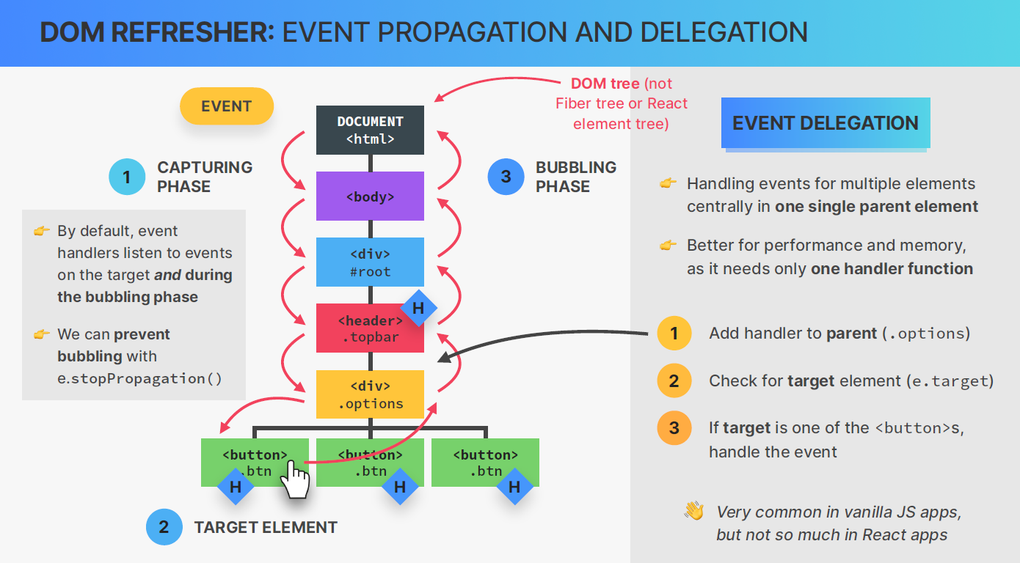

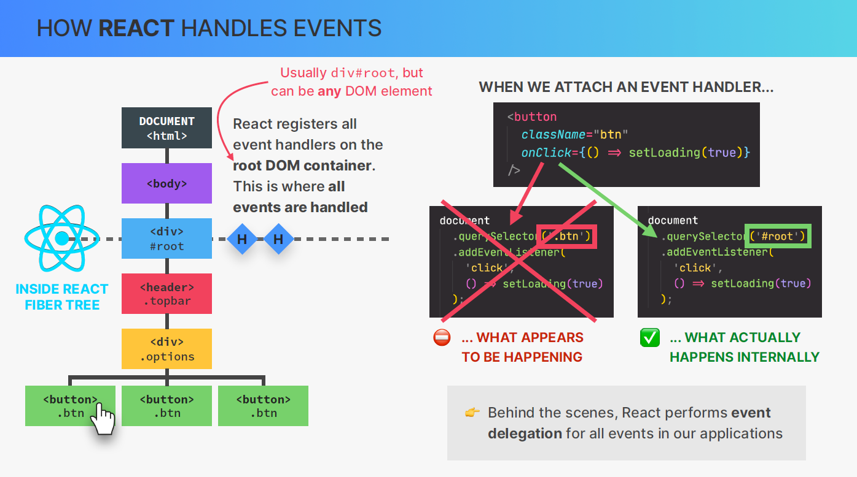

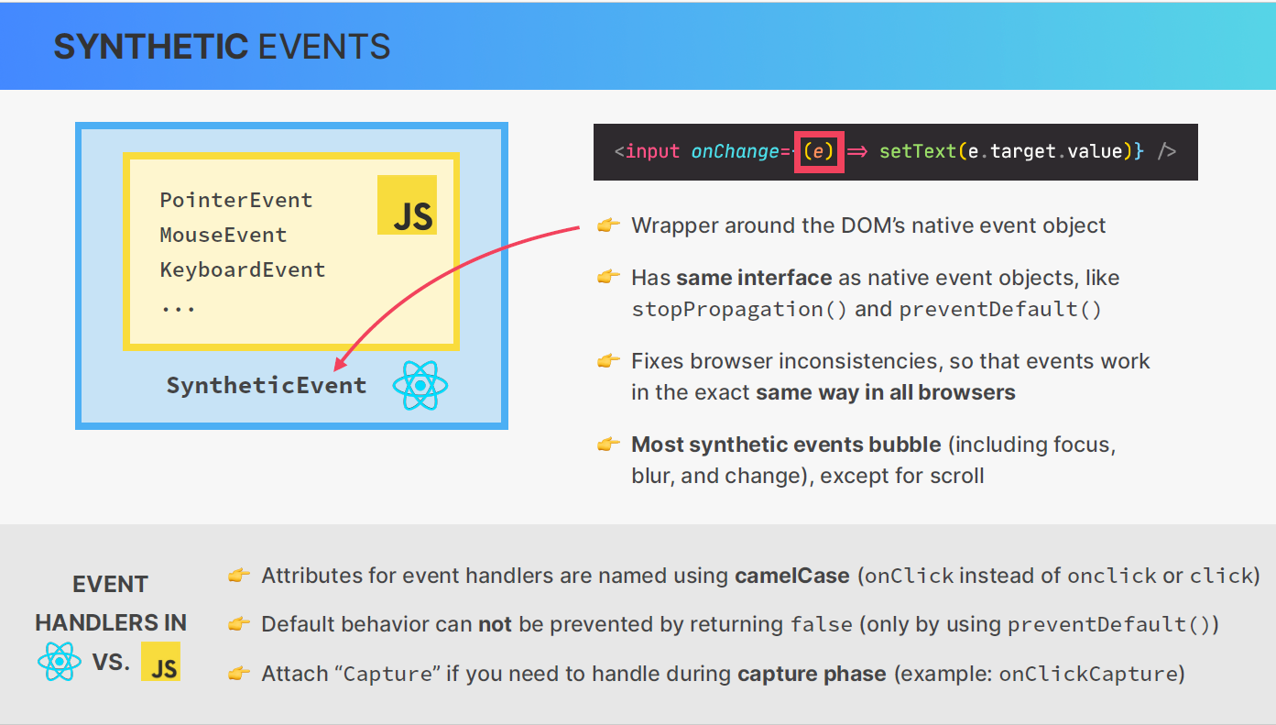

React encourages attaching event handlers to the most top-level element that makes sense. This is not necessarily the root DOM container but often a common ancestor for the elements you want to handle events on.

React uses event delegation internally to efficiently manage events on a higher level and delegate handling to the appropriate components.

**Do you find it helpful?**

**Let me know down in the comments**



[](https://www.linkedin.com/in/anubhav-gupta-b68946132/)

**Click To Follow For More On LinkedIN**